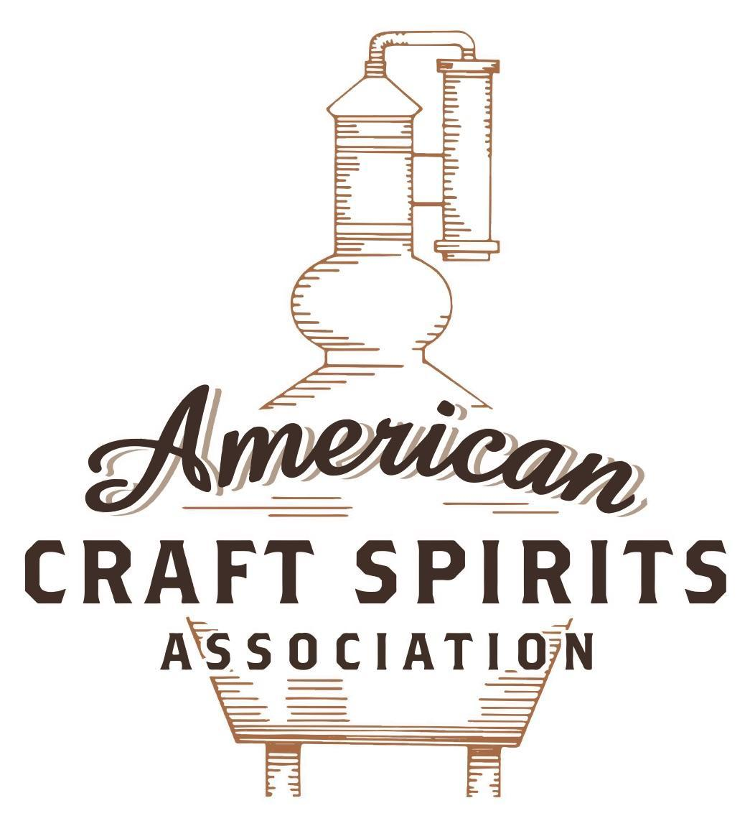
Spirits DtC Shipping Guide

This guide summarizes the direct-to-consumer shipping rules for distilleries in all 50 states and D.C. and also addresses the measures state governments have taken to ease delivery and shipping restrictions during the COVID-19 pandemic.

DtC Quick Guide Comparison

Out-of-State Distilleries  Can Ship Into State? |  |  |  | In-State Distilleries  Can Ship Within State?
State | Yes | No |  | State | Yes | No
AL |  | X |  | AL |  | X
AK | X |  |  | AK | X
AZ | X |  |  | AZ | X
AR |  | X |  | AR |  | X
CA |  | X* |  | CA |  | X*
CO |  | X |  | CO |  | X
CT |  | X* |  | CT |  | X
DE |  | X |  | DE |  | X
DC | X |  |  | DC | X
FL |  | X |  | FL |  | X
GA |  | X |  | GA |  | X
HI |  | X* |  | HI |  | ?*
ID |  | X |  | ID |  | X
IL |  | X* |  | IL |  | X*
IN |  | X |  | IN |  | X
IA |  | X* |  | IA |  | X*
KS |  | X |  | KS |  | X
KY | X |  |  | KY | X
LA |  | X |  | LA |  | X
ME |  | X* |  | ME |  | X*
MD |  | X |  | MD |  | X
MA |  | X |  | MA |  | X
MI |  | X |  | MI |  | X
MN |  | X |  | MN |  | X
MS |  | X |  | MS |  | X
MO |  | X |  | MO |  | X
MT |  | X |  | MT |  | X
NE | X |  |  | NE | X
NV |  | X* |  | NV |  | X
NH | X |  |  | NH |  | X*
NJ |  | X* |  | NJ |  | X*
NM |  | X |  | NM |  | X
NY |  | X* |  | NY |  | X*
NC |  | X |  | NC |  | X
ND | X |  |  | ND | X
OH |  | X |  | OH |  | X
OK |  | X |  | OK |  | X
OR |  | X |  | OR | X
PA |  | X* |  | PA |  | X
RI |  | X* |  | RI |  | X
SC |  | X |  | SC |  | X
SD |  | X |  | SD |  | X
TN |  | X |  | TN |  | X
TX |  | X |  | TX |  | X
UT |  | X |  | UT |  | X
VT |  | X |  | VT |  | X
VA |  | X |  | VA |  | X
WA |  | X* |  | WA | X
WV |  | X* |  | WV |  | X*

WI |  | X |  | WI |  | X
WY |  | X |  | WY |  | X

Notes:
*CA: If passed and signed into law, Senate Bill 620 would allow licensed distilled spirits producers in states other than California and licensed distilled spirits manufacturers or craft distillers in California who obtain distilled spirits direct shipper permits to ship directly to consumers in California
*CT: Consumers with appropriate permit may receive alcohol shipments
*HI: Consumers with appropriate permit may receive alcohol shipments; If passed and signed into law, Senate Bill 65 would allow licensed distilled spirits manufacturers in Hawaii and in states other than Hawaii who obtain direct shipper permits to ship directly to consumers in Hawaii
*IL: If passed and signed into law, Senate Bill 0532 would allow licensed distilled spirits producers in Illinois and in states other than Illinois who obtain distillery shippers’ licenses to ship directly to consumers in Illinois
*IA: If passed and signed into law, House File 639 would allow native distilled spirits manufacturers in Iowa and in states other than Iowa who obtain direct shipper permits to ship directly to consumers in Iowa and to consumers in states other than Iowa
*ME: If passed and signed into law, Legislative Document 1358 would allow distilleries outside of Maine with current manufacturer licenses and distilleries licensed in Maine who obtain spirits direct shipper licenses to ship directly to consumers in Maine
*NJ: (1) If passed and signed into law, Assembly Bill 3167 would allow a craft distillery licensees to ship no more than 9 liters of distilled spirits to a consumer in New Jersey; (2) If passed and signed into law, Senate Bill 3020 would allow craft distillery licensees in New Jersey or in states other than New Jersey to ship no more than 20 liters of distilled spirits to a consumer in New Jersey via common carrier
*NV: Licensed individuals can import one gallon per month of spirits for personal use and the out-of-state supplier must pay excise tax
*NH: If passed and signed into law, Senate Bill 125 would allow licensed liquor manufacturers who obtain direct to consumer shipping permits from the commission to ship directly to consumers in New Hampshire
*NY: Consumer may import up to 90L of liquor per year for personal use without a license; If passed and signed into law, Assembly Bill 3275 would allow licensed liquor manufacturers in states other than New York and licensed distillers and farm distillers in New York to ship no more than thirty-six cases (no more than nine liters per case) of liquor to consumers in New York
*PA: Consumer may place a special liquor order and distiller must ship to a PLCB-operated store
*RI: Distiller can only ship to customer if order was personally placed by customer at distiller's premises
*WA: If passed and signed into law, House Bill 1432 would allow licensed spirits manufacturers in states other than Washington to ship spirits to consumers in Washington
*WV: Distilleries, mini-distilleries, or micro-distilleries licensed in West Virginia or a state other than West Virginia who obtain private direct shipper licenses to ship to a consumer in West Virginia, however the shipments must be made to a retail liquor outlet

VERMONT
Shipment outbound – Silent as to distillers, although common carriers can only transport alcohol for direct wine or beer licensees (7 V.S.A. § 280).
Shipment inbound – No, all spirits imported or transported into Vermont must be imported or transported by and through the Board of Liquor and Lottery (7 V.S.A. § 63(a)(1)).
Shipment intra-state – No, manufacturers are allowed to sell directly to consumers at their licensed premises only (7 V.S.A. § 271; § 224).

COVID-19 Measures – Effective through June 30,2021, manufacturers with a 1st, 2nd, 3rd, or 4th class license were permitted to deliver alcohol to consumers. These measures ended after June 30, 2021. H. 313, signed and enacted into law on May 21, 2021, allows first-class and third-class licensees to sell spirits-based prepared drinks for off-premises consumption if the sale of alcoholic beverages for off-premises consumption is accompanied by a food order. The bill also allows second-class and fourth-class licensees to provide curbside pickup of unopened containers of alcoholic beverages that the licensee is permitted to sell from the licensed premises or location.
Executive Order No. 06-21 Link: https://governor.vermont.gov/sites/scott/files/documents/EXECUTIVE%20ORDER%20NO.%2006-21.pdf
H. 313 Link: https://legislature.vermont.gov/Documents/2022/Docs/ACTS/ACT070/ACT070%20As%20Enacted.pdf

Citation (shipment)

Vermont Statutes Annotated

7 V.S.A. § 63. Importation or transportation of alcohol; prohibitions; personal import limit; penalty
(a)(1) All spirits and fortified wines imported or transported into this State shall be imported or transported by and through the Board of Liquor and Lottery. A person importing or transporting or causing to be imported or transported into this State any spirits or fortified wines, or both, in violation of this section shall be imprisoned not more than one year or fined not more than $5,000.00, or both.
Link: https://legislature.vermont.gov/statutes/section/07/003/00063
7 V.S.A. § 224. Fourth-class licenses
(a) The Board of Liquor and Lottery may grant up to a combined total of ten fourth-class licenses to a manufacturer or rectifier that submits an application and the fee provided in section 204 of this title.
(b) At each licensed location, a fourth-class licensee may sell by the unopened container or distribute by the glass, with or without charge, alcoholic beverages manufactured by the licensee.
(1) A licensee may, for consumption at the licensed premises or location, distribute the following amounts of alcoholic beverages to a retail customer:
(A) no more than two ounces of malt beverages or vinous beverages with a total of eight ounces; and
(B) no more than one-quarter ounce of spirits or fortified wine with a total of one ounce.
(2) At a fourth-class license location at the licensee's manufacturing premises, the licensee may distribute by the glass up to four mixed drinks containing a combined total of no more than one ounce of spirits or fortified wine to each retail customer for consumption only on the licensed premises.
(3) At each licensed location, a fourth-class licensee may, pursuant to section 64 of this title, sell malt beverages or vinous beverages, or both, by the keg.
(c)(1) At only one fourth-class license location, a licensed manufacturer or rectifier may sell by the unopened container or distribute by the glass, with or without charge, alcoholic beverages produced by no more than five additional manufacturers or rectifiers, provided these beverages are purchased on invoice from the manufacturer or rectifier. (2) A manufacturer or rectifier may sell its product to no more than five additional manufacturers or rectifiers.
(d) A fourth-class license issued for a farmers' market location shall be valid for all dates of operation for the specific farmers’ market location.
(e) Rules applicable to second-class licenses and pertaining to financial responsibility, age of employees, the selling and furnishing to apparently intoxicated persons; and leases of businesses shall all apply to fourth-class licenses.
(f) Signs and advertising of fourth-class licenses at tasting rooms and retail shops other than at the manufacturer's or rectifier’s premises shall indicate that the premises are a "tasting room and retail shop," and shall be in lettering not less than 75 percent of the height and width of the lettering setting forth the name of the licensee or establishment.
Link: https://legislature.vermont.gov/statutes/section/07/009/00224
7 V.S.A. § 271. Manufacturer's or rectifier's license
(b) Except as otherwise provided in section 224 of this title and subsections (d)-(f) of this section:
(1) spirits and fortified wine may be manufactured for sale to the Board of Liquor and Lottery or for export, or both; and
(d)(1) The Board of Liquor and Lottery may grant to a licensed manufacturer or rectifier a first-class license or a third-class license, or both, permitting the licensee to sell alcoholic beverages to the public at an establishment located at the manufacturer's or rectifier's licensed facility, provided the manufacturer or rectifier owns or has direct control over that establishment.
(2) A licensed manufacturer of malt beverages may operate up to two licensed establishments pursuant to this subsection that are located at the licensed manufacturing facility or on property that is owned by the licensee and is contiguous with the parcel of land on which the licensed manufacturing facility is located, provided the manufacturer owns or has direct control over both establishments.
(f)(1) A licensed manufacturer or rectifier may serve alcoholic beverages with or without charge at an event held at the licensed manufacturing or rectifying facility or at a location on property that is owned by the licensee and is contiguous with the parcel of land on which the licensed facility is located, provided the licensee at least five days before the event gives the Division written notice of the event, including details required by the Division.
(2) Any beverages not manufactured by the licensee that are served at the event shall be purchased on invoice from a licensed manufacturer or wholesale dealer or the Board of Liquor and Lottery.
Link: https://legislature.vermont.gov/statutes/section/07/009/00271
7 V.S.A. § 280. Common carriers; requirements
(c) A certified common carrier shall deliver only malt or vinous beverages that have been shipped by the holder of a license issued under section 277 or 278 of this subchapter or vinous beverages that have been shipped by the holder of a vinous beverage storage license issued under section 283 of this subchapter.
Link: https://legislature.vermont.gov/statutes/section/07/009/00280
Citation (COVID-19)
RETAIL DELIVERY of ALCOHOL to CUSTOMERS 1st, 2nd and 4th Class Licensees
5.c.iii has been Amended 3/25/2020 – as part of the delivery process
5. For deliveries, the licensee shall be able to travel from town to town or from place to place carrying orders for delivery of any alcohol product they are licensed to sell and authorized to deliver hereunder without a delivery permit, provided the following conditions are met:
a. The person making the delivery is at least 18 years old and is certified to sell or serve alcohol by the Board. b. All deliveries shall be in person to a physical building or residence.
c. Licensees shall maintain an inspectable log of all deliveries made and such log shall at a minimum include:
i. Name of recipient and physical address in Vermont to where the product was delivered.
ii. How ID was verified.
iii. A signature of recipient at least twenty-one (21) years of age; AMENDED; to ensure social distancing, the 21-year-old recipient will not be required to a sign.
iv. Complete description of the product and quantity delivered.
v. Time of delivery.
vi. The name of the employee making the delivery.
Link: https://liquorcontrol.vermont.gov/sites/dlc/files/documents/DLC_Covid-19_FAQ.pdf

The American Craft Spirits Association (ACSA) is working diligently to give our members and industry partners relevant, current updates on statutes and regulations impacting production, sale and distribution of spirits. With the declaration of the novel coronavirus (COVID-19) in early 2020, many states have issued temporary policy changes or longer-term modernization of alcohol beverage laws. State statutes, regulations created by the state alcohol regulatory authority, as well as any other relevant guidance provided by such authorities (such as advisories, opinions, bulletins, etc.) were reviewed in creation of this document. No city or county ordinances were reviewed. Distillers should be aware that even in states where direct shipping is permissible, always remember to avoid shipping to dry counties. Please consult with your state guild or alcohol beverage authority for the most up-to-date information. This content is intended for educational and informational purposes only. ACSA's pro bono law firm of Malkin Law P.A. provided the core content found in this comprehensive overview of the spirits distribution after COVID-19. It was completed in August 2021 and will be updated regularly. If you have updates you would like to provide, please send to legislation@americancraftspirits.org or directly to the law firm at: ryan@malkin.law / malkin.law. Thank you.

